Name : Shadab Alam
University Roll no : 2315002021
Section : Trailblazers(B)
Topic: Array
Question 448
class Solution {
public List<Integer> findDisappearedNumbers(int[] nums) {
int arr[] = new int [nums.length];
ArrayList<Integer> numbers = new ArrayList<>();
for (int x : nums){
arr[x-1]++;
}
for (int i = 0 ;i<nums.length;i++){
if ( arr[i] == 0 ) numbers.add(i+1);
}
return numbers;
}
}
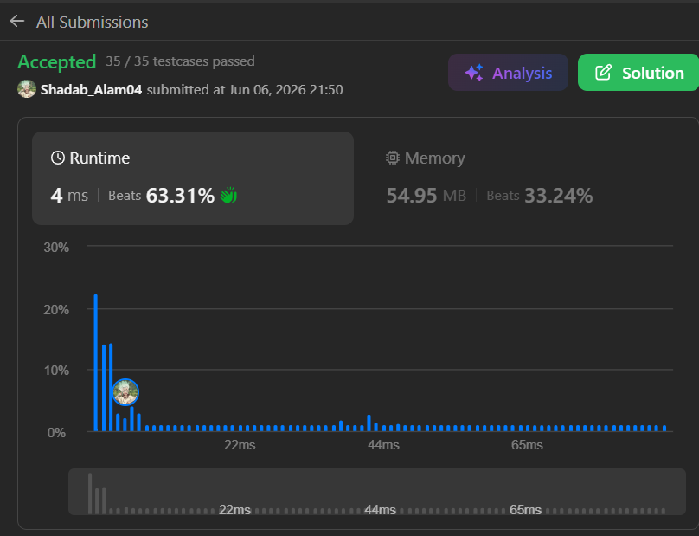

Question 1636
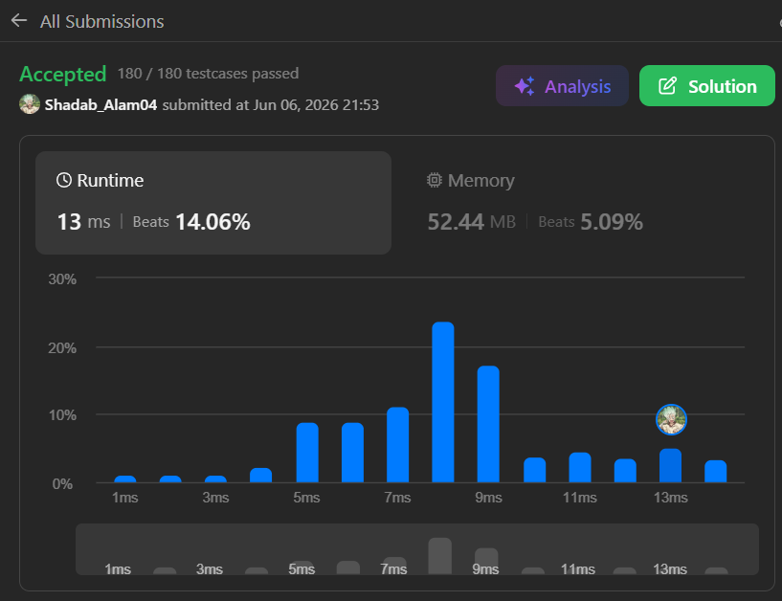

Question 347
import java.util.*;
class Solution {
public int[] topKFrequent(int[] nums, int k) {
HashMap<Integer, Integer> map = new HashMap<>();
for (int num : nums) {
map.put(num, map.getOrDefault(num, 0) + 1);
}
int[] ans = new int[k];
int idx = 0;
while (idx < k) {
int maxFreq = -1;
int maxNum = 0;
for (int num : map.keySet()) {
if (map.get(num) > maxFreq) {
maxFreq = map.get(num);
maxNum = num;
}
}
ans[idx++] = maxNum;
map.put(maxNum, -1);
}
return ans;
}
}
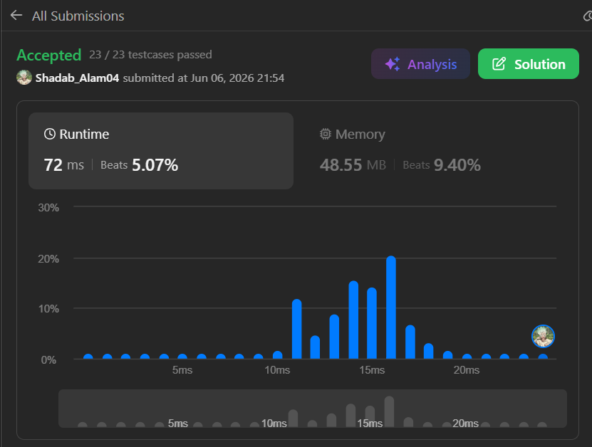

Topic: Matrix
Question 1351
class Solution {
public:
int countNegatives(vector<vector<int>>& grid) {
int m = grid.size();
int n = grid[0].size();
int count = 0;
for (int i = 0; i < m; i++) {
int left = 0;
int right = n - 1;
int firstNegative = n;
while (left <= right) {
int mid = left + (right - left) / 2;
if (grid[i][mid] < 0) {
firstNegative = mid;
right = mid - 1;
} else {
left = mid + 1;
}
}
count += (n - firstNegative);
}
return count;
}
};

Topic: String
Question 67
class Solution {
public:
string addBinary(string a, string b) {
int A= a.length()-1;
int B= b.length()-1;
int carry=0;
int sum=0;
string ans="";
while(A>=0 || B>=0 || carry >0)
{
sum=carry;
if(A>=0)
{
sum=sum + a[A]-'0';
A--;
}

if(B>=0)
{sum=sum + b[B]-'0';
B--;
}

ans= char(sum%2 + '0') +ans;
carry=sum/2;
}
return ans;
}
};

Question 344
class Solution {
public void reverseString(char[] s) {
int left=0;
int right=s.length -1 ;
while(left<right){
char temp=s[left];
s[left++]=s[right];
s[right--]=temp;
}
}
}

Question 389
import java.util.Arrays;
class Solution {
public char findTheDifference(String s, String t) {
if (s.isEmpty()) {
return t.charAt(0);
}
char[] sArr = s.toCharArray();
char[] tArr = t.toCharArray();
Arrays.sort(sArr);
Arrays.sort(tArr);
for (int i = 0; i < sArr.length; i++) {
if (sArr[i] != tArr[i]) {
return tArr[i];
}
}

return tArr[tArr.length - 1];
}
}
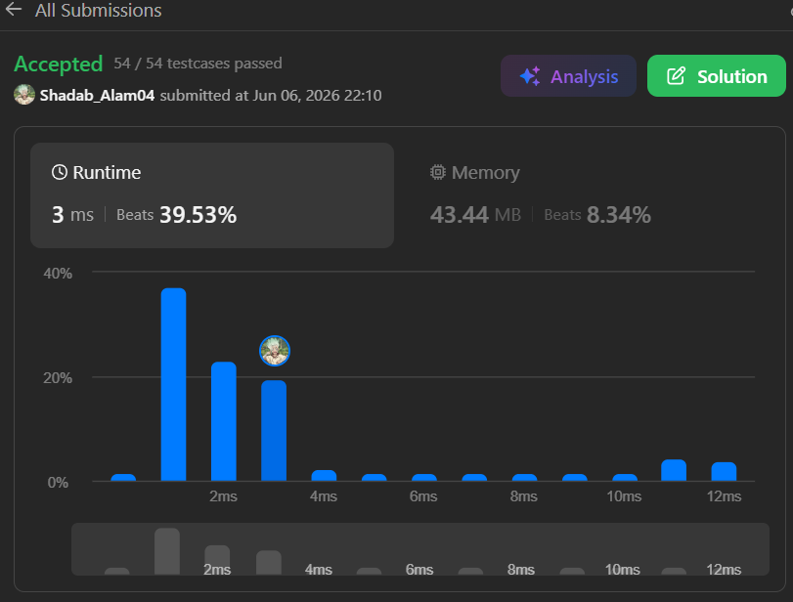
Topic: Stack
Question 150
class Solution {
public int evalRPN(String[] tokens) {
Stack<Integer> st = new Stack<>();
for (String i : tokens){
if ( i.equals("+")){
int b = st.pop();
int a = st.pop();
st.push(a + b);
}
else if ( i.equals("-")){
int b = st.pop();
int a = st.pop();
st.push(a - b);
}
else if ( i.equals("*")){
int b = st.pop();
int a = st.pop();
st.push(a * b);
}
else if ( i.equals("/")){
int b = st.pop();
int a = st.pop();
st.push(a / b);
}
else {
st.push(Integer.valueOf(i));
}
}
return st.pop();
}
}
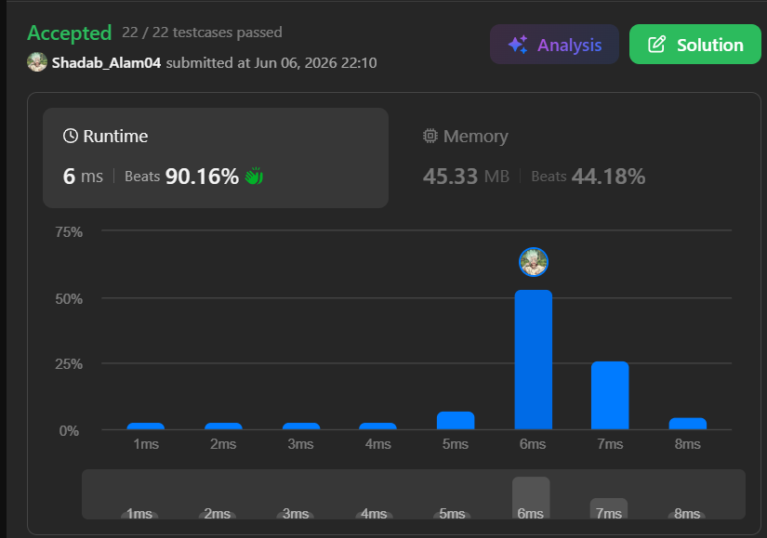
Topic: Sliding Window
Question 1456
class Solution {
private boolean isVowel(char c) {
return c == 'a' || c == 'e' || c == 'i'
|| c == 'o' || c == 'u';
}
public int maxVowels(String s, int k) {
int count = 0;
for (int i = 0; i < k; i++) {
if (isVowel(s.charAt(i))) count++;
}
int ans = count;
for (int i = k; i < s.length(); i++) {
if (isVowel(s.charAt(i - k))) count--;
if (isVowel(s.charAt(i))) count++;
ans = Math.max(ans, count);
}

return ans;
}
}
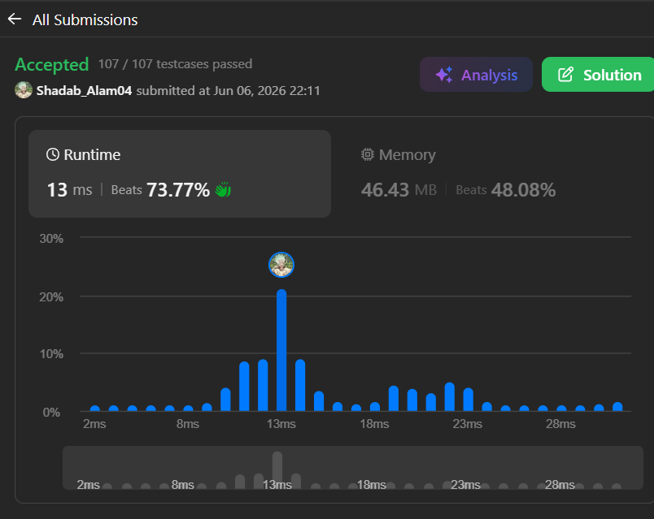
Topic: Binary Search
Question 1482
class Solution {
private int[] bloomDay;
private int m, k;
public int minDays(int[] bloomDay, int m, int k) {
this.bloomDay = bloomDay;
this.m = m;
this.k = k;
final int mx = (int) 1e9;
int l = 1, r = mx + 1;
while (l < r) {
int mid = (l + r) >> 1;
if (check(mid)) {
r = mid;
} else {
l = mid + 1;
}
}
return l > mx ? -1 : l;
}
private boolean check(int days) {
int cnt = 0, cur = 0;
for (int x : bloomDay) {
cur = x <= days ? cur + 1 : 0;
if (cur == k) {
++cnt;
cur = 0;
}
}
return cnt >= m;
}
}
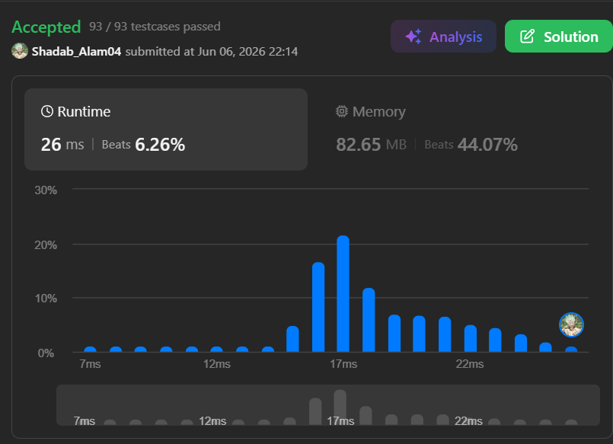
Topic: Recursion
Question 1342
class Solution {
public int numberOfSteps(int num) {
if (num == 0) {
return 0;
}
if (num % 2 == 0) {
return 1 + numberOfSteps(num / 2);
}
return 1 + numberOfSteps(num - 1);
}
}

Topic: Bit Manipulation / Math’s / Binar Search
Question 231
class Solution {
public boolean isPowerOfTwo(int n) {
return n >= 0 && Integer.bitCount(n) == 1;
}
}
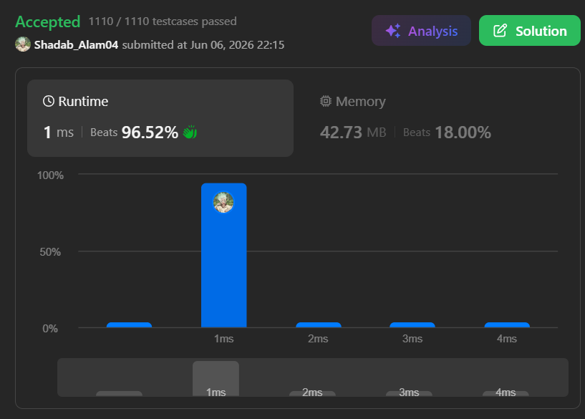
Question 326
class Solution {
public boolean isPowerOfThree(int n) {
if (n == 1) return true;
if (n <= 0 || n % 3 != 0) return false;
return isPowerOfThree(n / 3);
}
}

Question 338
class Solution {
public int[] countBits(int n) {
int ans [] = new int [n+1];
for ( int i = 0 ; i <= n ; i++ ){
ans[i] = Integer.bitCount(i);
}
return ans;
}
}

Question 191

class Solution {
public int hammingWeight(int n) {
/* int c = 0;
while(n>= 1){
if(n%2 == 1 )c++;
n = n/2;
}
return c ; */
return Integer.bitCount(n) ;
}
}


